Lecture: 14:44, in report make it clear to staring point and ending point

Decomposing vision - strategy – effort

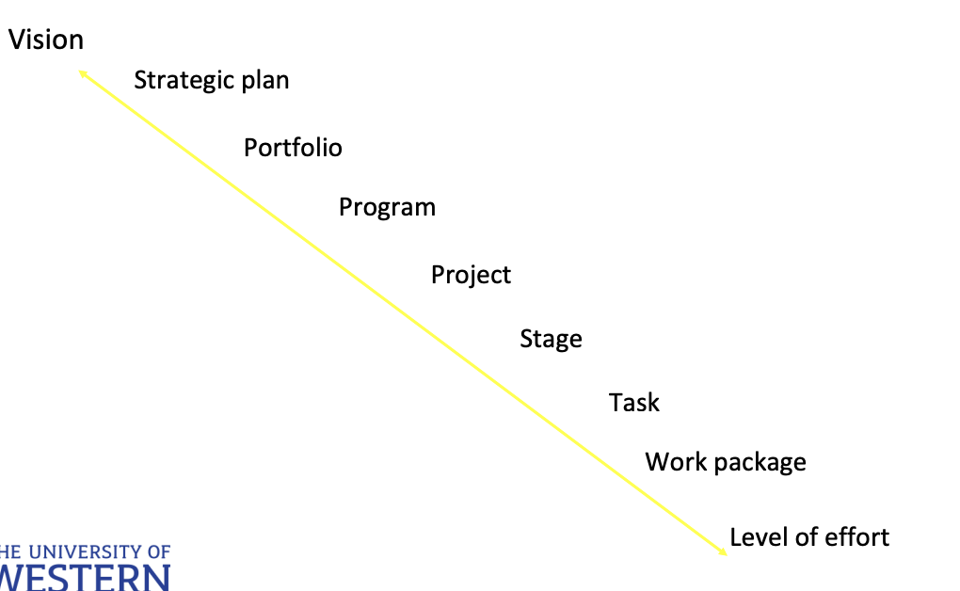

Vision & project success

Compare organizational vision with project vision

* Understand the big picture
* Credible with figure
* Motivate stakeholder

Effective communication is the most important for PM

Deconstructing strategy

* Change initiator get more benefit. Many company wait for other to change.
  + If long term sustainable change apply, that is good

战略代表了组织旨在实现的总体方向或目标集。它通常由高级管理层定义，旨在指导业务的长期发展

目标是从更广泛的战略中衍生出来的具体的、可衡量的目标。这些目标旨在明确和可操作

目标导致运营，这是指运营业务所需的日常活动。这些是维持当前业务状态的常规、持续的流程和功能

目标导致变化，意味着需要转型或适应以实现战略目标，涉及启动项目，这些项目是具体的、有时限的举措，旨在创造变革并实现符合战略目标的特定成果

## Role of an inspiring strategy

* High level included/long term goal
* Identify strengths, weaknesses, opportunities, and threats (SWOT)
  + strengths, weaknesses internal
  + opportunities, threats external
* Be future, value and results oriented
* Integrated whole company
* Provide coherence and momentum
  + E.g: we are sustainable, unique
* Be qualitative in design to observe the change
* Long term focus, 10 year or longer

## Maintaining the credibility and process of change

* Vision before plan and progress, or easily dissolve to confusing/incompatible project
* Managing project changes
  + Internal & external factors
    - Internal: vision
    - external: covid
  + Assumption of future event, listen to expert and keep informed
  + Applied change then monitoring/inform stakeholders, make them happy

## Strategic investment and Portfolio: Justification

* Return on Investment (ROI) & Profitability Growth: Ensuring financial returns and long-term profitability.
* Cost Efficiency: Reducing costs through optimized processes and resource utilization.
* Competitive Advantage: Gaining an edge over competitors through innovation and market positioning.
* Sponsor/Client Advantage: Meeting the needs and expectations of sponsors and clients.
* Product Mix Diversity: Diversifying the product portfolio to mitigate risks and explore new markets.
* Consistency with TBL & Life Cycle Thinking: Ensuring projects are sustainable and consider economic, environmental, and social impacts throughout their lifecycle. This approach promotes long-term viability and reduces negative externalities.

## (REMEMBER THIS)Project selection models

### Non-numeric

* Sacred cow
  + E.g. Owner of the company require the project
  + Lack of company support （当组织内的领导者积累过多的权力和资源，专注于扩大自己的控制范围而不是组织的整体利益时，就会发生帝国建设。扼杀其他地方的创新）
* Operating necessity
  + Happen during crisis/covid, reduce budget/time and wait external factor ended
* Competitive necessity
  + Maintaining a competitive advantage, leader in industry
  + May negative profit, may turn profit few year
  + Insufficient industry analysis, Little competitor analysis（当一个组织意识到其缺乏行业分析时，它可能会启动项目来加深对市场的了解，确定新的客户需求，或重新评估竞争格局）
* Comparative benefit
  + Compare multiple projects with differ benefit
  + Support for high profit projects
* Product line extension
  + After make profit of old project (car), the sale goes down
  + Use data analysis and intuition, understand the demand change
  + Try fill the market gap, but risk reduce market share/profit
  + 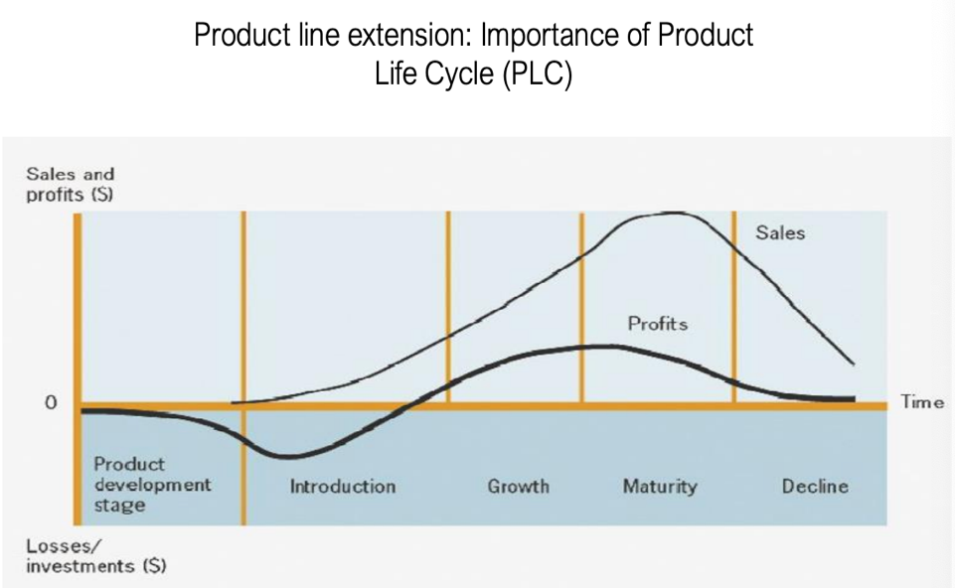
  + Timing is important.
  + E.g: add feature and make a new generation of car

### Numeric models

* Payback period
  + time takes to earn back money invested = Cost of project/annual cash revenue
  + if revenues expected vary yearly, add revenues expected for each year till reach total cost
  + model doesn’t consider the time-value of money. Any additional cash flow (after year 4) are of no use with this mode
* Return on investment (ROI)
  + (popular method) = overall profit (or loss) on an investment calculated as a percentage (%) of the total amount invested
  + = net profit/total investment x 100
  + E.g: net profit of $40,000 over a period of 6 years, & the total investment is $100,000 the ROI is: $40,000/$100,000 x 100 = 40% return
* Net present value (NPV)
  + = Cash flow x discount factor
  + Discount factor = 1/(1+i)^n - (from annuity table – e.g. in finance, data analysis, accounting texts)
  + Application of NPV
  + 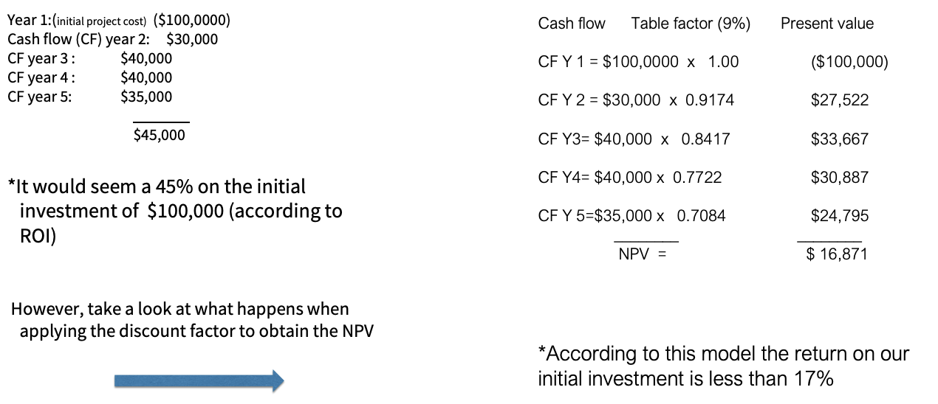
  + Only right side is NPV, left is ROI
  + 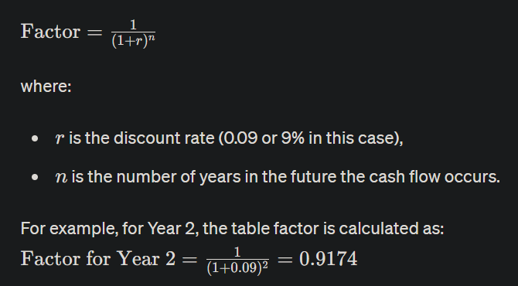
  + lecture 36:53

### Prioritizing

* Client classification
* ROI/cost saving
* Impact & portfolio management
* Resource capability/availability and time to implement
* Scale of complexity risk exposure

E.g. how to scale & classify projects.

## Defining (project) governance

* Define role and responsibilities of all stakeholders, decision making structure of project
* Plan manage project ensuring accountability: transparency, participation, predictability, traceability, validation and integrated change controls
* Regular, timely, unambiguous, result drive report on performance deliverable and outcome
* Expectations and benefits
  + Clear roles/ responsibilities
  + Develop project capability
  + Accountability transparency in make decision
  + Maximize return on project investment
  + Identify communication management of all stakeholder
  + review & evaluate documents & deliverables
  + consistency with TBL and project life cycle

Stakeholder power and interest matrix

* Minimal effort: low interest, low power—informal, unstructured, updates as required
* Keep informed: high interest, low power—semi-formal, structured, observe and respond as required
* Keep satisfied: high power, low interest—regular formal, structured communication to maintain and reward confidence
* Manage closely: high interest, high power—formal, structured and scheduled consultation and engagement

## Project stakeholders

* two types: contribute vs benefit
* they can support or hinder your project
* cannot be ignored, impact ultimate success
* must be identified
* need to be managed

## Project clients

* Ensures outcomes meet customer organization needs.
* Approves changes to project scope and deliverables
* Provides funding
* Realizes project business benefit
* Aligns project with organizational strategies and goals.

## Project sponsor

* Holds ultimate accountability for the project.
* Sets business objectives.
* Secures ongoing project funding.
* Regularly monitors costs, risks, and progress.
* Approves scope changes.
* Ensures organizational commitment.
* Provides leadership and high-level support.
* Manages negotiations and financial analysis.

## Clients vs sponsor

* client looks at the project from an external perspective as a recipient of the project's output, whereas the sponsor views it from an internal strategic perspective, ensuring it aligns with the business’s goals.
* Clients may not be involved in the activities of the project but are crucial in the planning and acceptance phases. sponsors are more engaged throughout the project lifecycle, from initiation through closure.
* Sponsors generally have higher authority, They can make decisions about project continuation, funding, and scope changes, while clients typically have authority over accepting the project's final output

## Steering group

* The senior management team monitors the activities of an organisation and gives guidance on the general direction that should be taken
* 主要工作是项目经理的导师和教练，提供指导和支持，帮助他们成功管理和交付项目，类似项目里的审计
* Balancing competing priorities, resources, guidance & direction
* Review benefits delivered by project

## Project team member

* Execute specific project tasks and deliverables.
* Offer technical expertise and problem-solving.
* Communicate issues and progress.
* Participate in project meetings and reporting.
* Directly involved in operational project execution.

## Steering group vs Project team member

* The steering group is involved at a higher, more strategic level, while project team members are involved in the ground-level operations and execution of the project.
* Steering group members have the authority to make broad strategic decisions and provide overall project guidance, whereas project team members are responsible for executing tasks and deliverables within the framework set by the steering group.
* The focus of the steering group is on the project with business strategies, managing high-level risks, and ensuring the project meets its overall goals. In contrast, project team members focus on the practical aspects of creating and implementing the project's deliverables.

## Project manager

* Developing the project plan
* Manages resources, schedule, and budget.
* Coaches and supports the project team.
* Manages changes, impacts, and approvals.
* Ensures quality standards are met.
* Tracks and reports project performance.
* Profiling
  + Technical skills
  + Managerial ability
  + Business thinking
  + Project management software skills
  + Project management discipline
  + Strategic expertise

## Plan stakeholder management

* Create a plan to engage stakeholders based on their interest in the project.
* Manage expectations and align them with project goals.
* gather important information from each stakeholder, considering their roles and responsibilities.
* Keep records in an easily accessible format that can be updated and shared as the project advances.
* Here are two frameworks for it: RACI and PARIS

### RACI framework nominate stakeholder

* Responsible: charged with doing required activities
* Approve: who approve all decisions
* Consult: who needs to be consulted prior, during or after an action
* Inform: who needs to be kept informed of progressive actions

### PARIS

* Participate: stakeholder charged with doing the required activities
* Approve: stakeholder who needs to approve all decisions
* Review: charged with conducting required activities
* Inform: who needs to be kept informed of progressive actions
* Signoff: provides official signoff

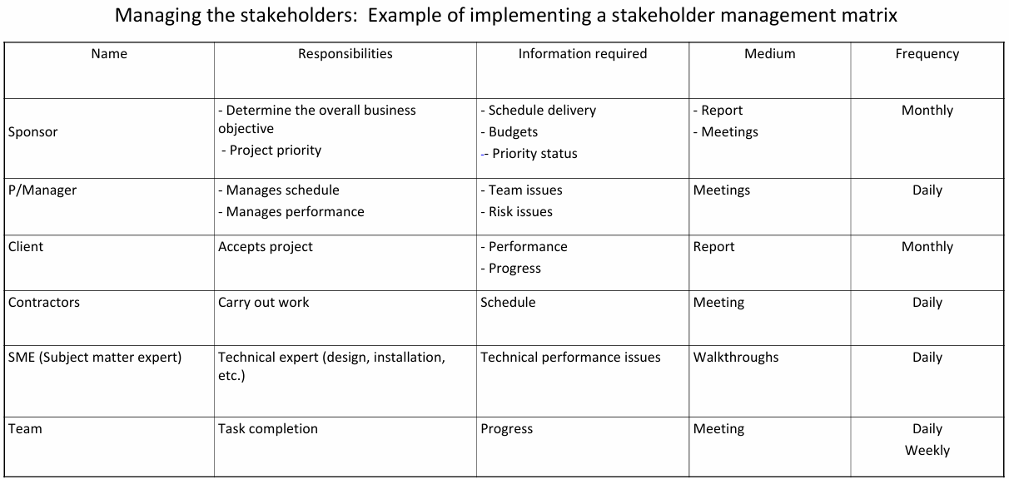

## Response strategies to stakeholder pressures

* Follow the rules and demands set by stakeholders更顺利的项目执行，因为它最大限度地减少了阻力和冲突。通过遵守利益相关者的期望，项目更有可能获得他们的持续支持和资源
* Talk with stakeholders, listen to their needs, and make fair adjustments妥协可以在项目团队和利益相关者之间建立信任与合作。它确保在考虑利益相关者利益的同时，项目的目标不会完全被边缘化
* Reduce ties with demanding stakeholders and let others handle their claims当利益相关者的要求不合理或满足这些要求, 团队可以专注于核心活动，并可能降低项目的复杂性和风险
* Ignore stakeholder demands and exclude their requirements from project implementation这种方法可用于利益相关者权力最小，或者他们的利益与项目或组织的战略目标发生重大冲突的情况
* demonstrating project value and fostering strong relationships

## managers & leaders

* Managers - Achieve results with & through others
* Leaders - Get people to do things willingly that they otherwise would not do

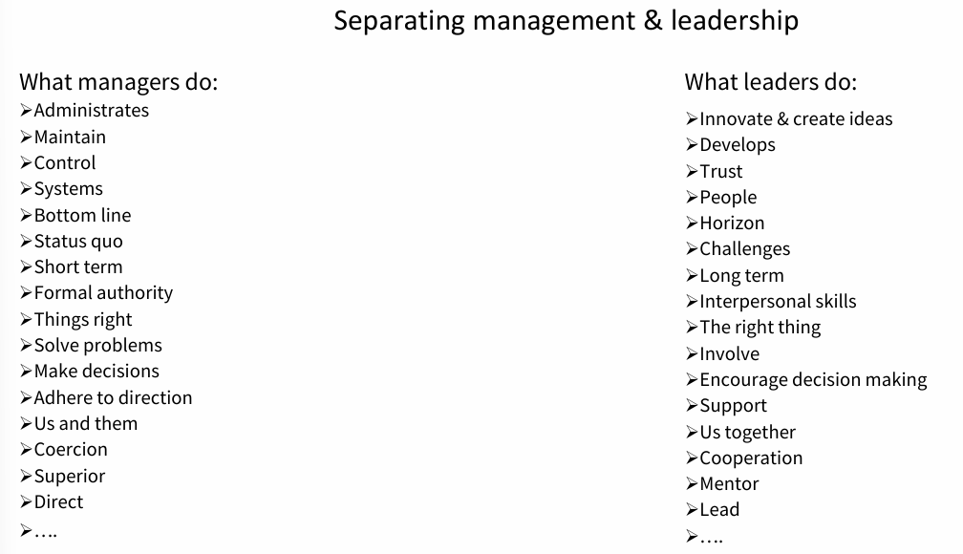

Answer: